
Component Model
UPD Processing
Robotic Cognition System for Wheelchair
Unicamp

Table of Contents
1 Purpose of this Document 3
2 Component Design 4
2.1 Purpose 4
2.2 System Diagram 4
2.3 Component Input 4
2.4 Component Output 4
2.5 Component Processing 4
3 Component Execution 6
4 References 8

Document Information
Project Name: | Robotic Cognition System for Wheelchair
Prepared By: | Tarcísio Franco de Carvalho | Document Version No: | 1.0
Title: | Component Model – UPD Processing | Document Version Date:
Reviewed By: |  | Review Date:
Distribution List
From | Date | Email

Acronyms
Acronym | Description
UPD | Unevenness Point Data
ROS | Robot Operational System

Document Version History
Version  Number | Version  Date | Revised By | Description | Filename

Purpose of this Document
Define how the related component works and its relation in the main system.

Component Design

Purpose
This component is responsible to execute the transversability analysis on the point cloud data captured by a depth-sensing camera as Microsoft Kinect. The transversability analysis produced by this component will be one of the inputs to classify the ground passage condition for a wheelchair robot.

System Diagram

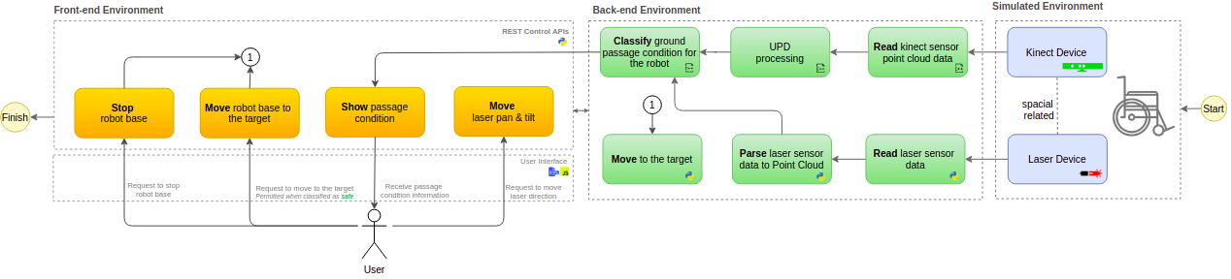

Component Input
This component reads the ROS node “/camera/depth/points” that publishes the depth-sensing data in Point Cloud format on a defined cycle. The point cloud data is stored in a variable to be processed.

Component Output
This component publishes the transversability analysis in point cloud data format on the ROS node “/upd_point_cloud_classification” on a defined cycle.

Component Processing
This component has relationship with the camera depth points ROS node, UPD library and a publisher ROS node to publish the output data. The diagram below shows this relationship:

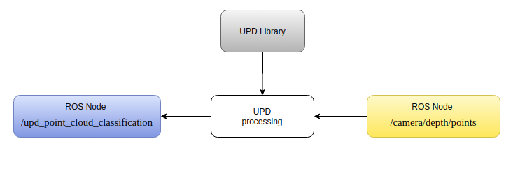

Below the main process flow for this component that runs in cycles:

- Read point cloud data from /camera/depth/points ROS node
- Remove noise data from point cloud
- Compress point cloud data
- Reduce the scope of points using the Vox Grid approach
- Set up UPD library parameters
- Process the point cloud data with UPD library
- Transform UPD processed point cloud
  - Rotate counter clockwise in y axis
  - Rotate clockwise in z axis
- Publish the UPD processed point cloud to /upd_point_cloud_classification ROS node

Component Execution

To execute this component is necessary the Gazebo simulation environment, ROS main process running and the Rviz tool to show processed data. Bellow the steps to run this component:

- Start Gazebo environment simulation
On the project root folder, run the script ./sim_model/scripts/launch.sh it will process the simple_blocks.world and sim_model.urdf.xacro files

Result
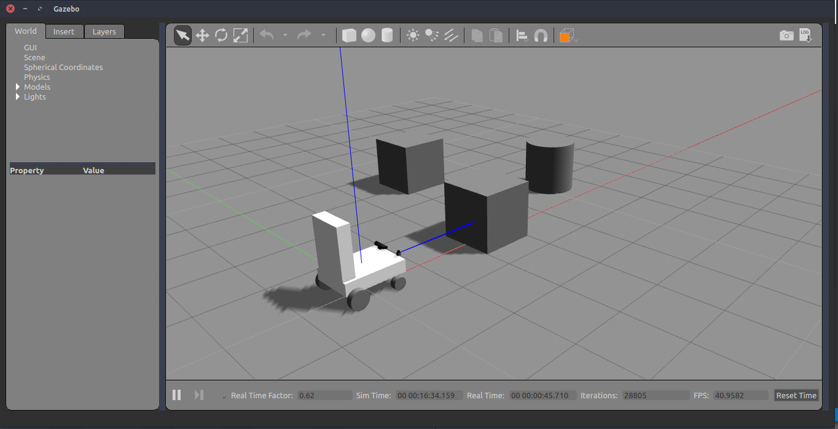

- Start the UPD processing component

On the project root folder, run the script ./upd_run.sh it will start a node to published UPD data

Result
In Rviz the UPD data is being showing.

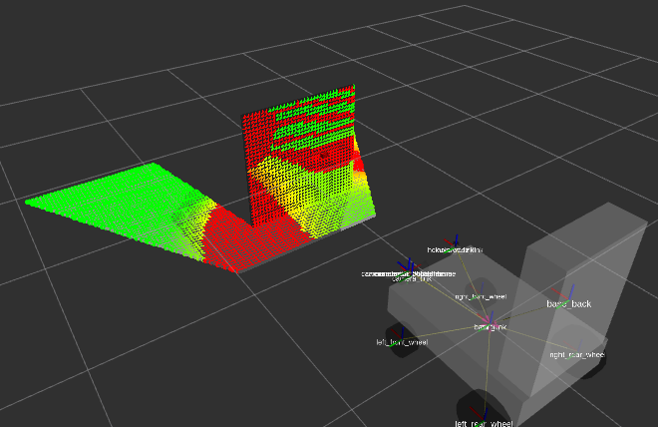

References

- Open Transversability
  - UPD Home Page - http://www.maurobellone.com/robotics/upd_demo
  - UPD Git Hub - https://github.com/bellonemauro/OpenTraversability
- Point Cloud
  - Downsampling a PointCloud using a VoxelGrid filter - http://vml.sakura.ne.jp/koeda/PCL/tutorials/html/voxel_grid.html
  - Voxel - https://en.wikipedia.org/wiki/Voxel
  - Estimate the transformation matrix between two set of points (PCL): https://machinelearning1.wordpress.com/2014/02/09/estimate-the-transformation-matrix-between-two-sets-of-points-pcl/
- ROS
  - ROS and Gazebo for Depth Camera: http://gazebosim.org/tutorials/?tut=ros_depth_camera
  - Control: http://wiki.ros.org/ros_control
  - ROS and Gazebo Tutorial: http://wiki.ros.org/action/fullsearch/urdf/Tutorials/Using%20a%20URDF%20in%20Gazebo?action=fullsearch&context=180&value=linkto%3A%22urdf%2FTutorials%2FUsing+a+URDF+in+Gazebo%22
- Others
  - Rotation Matrix: https://en.wikipedia.org/wiki/Rotation_matrix
  - Rotating project point: http://www.pcl-users.org/Rotating-projected-point-cloud-to-get-z-0-for-all-points-td4034031i20.html
  - C++ Eigen Matrix: https://eigen.tuxfamily.org/dox/group__TutorialMatrixClass.html

